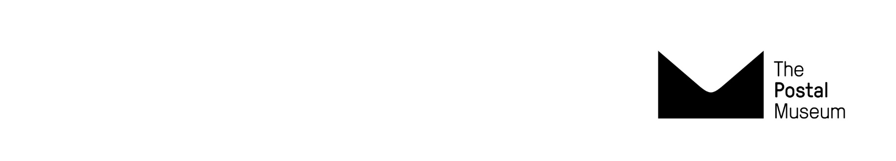
Terms and conditions for schools
Museum Visits 2025-26

All booked schools and learning group visits are subject to these terms and conditions.

Booking
- Advance booking is essential. Schools must complete a booking request form in full. We will be in contact within 5 working days to confirm/discuss your booking request. Then we will send a booking confirmation email. Check your booking details carefully and get in touch if any information is incorrect.
- Schools will be sent an invoice by email with a 30-day payment term. Payment is by BACS transfer or cheque. Bookings under £100 can be paid by card over the phone. Payment in full is due at least 7 days before your visit date.
- It is the responsibility of the person booking to ensure your finance team has received the invoice and it is paid on time. If payment is not made before your visit, bookings may be cancelled.
- Schools can book a visit at shorter notice depending on availability. In this case payment is expected before the visit date and may be requested immediately.
- Booking changes may be possible depending on availability. Requests to amend your itinerary or group size must be made in writing at least six weeks before your visit date. Changes will be confirmed by email. Schools that bring more students or adults than confirmed in your booking, may be asked to pay student/adult rates.
Cancellations
- School cancellations for a confirmed booking received in writing at least six weeks before your visit date will incur no charge. We cannot guarantee to move bookings after this point and schools may be charged 100% of the visit cost.
- Museum cancellations may occur in rare unforeseen circumstances. We will contact schools as soon as we can and offer alternative visit dates. Regrettably we cannot reimburse travel or other costs.
Late arrivals
- If you are running late, call the number on your itinerary as soon as possible. We will discuss options, but we cannot guarantee to change activity times or provide refunds for missed activities.
Health and safety
- Risk assessments are the responsibility of teachers. Teachers can request a free planning visit. Our website includes risk assessment guidance notes including access requirements for the Mail Rail ride.
- Adult:student supervision ratios are below. These are essential to provide adequate supervision. We may refuse entry to schools that do not meet these ratios.
- EYFS Nursery 1:3
- EYFS Reception 1:4
- KS1 1:4
- KS2 1:6
- KS3 1:10
- KS4+ 1:15

- Disruptive behaviour in the museum may result in a group being asked to leave. You are responsible for ensuring all adult helpers are aware of the supervision requirements.
- The Postal Museum’s Safeguarding Policy can be read here.
Personal belongings
- We accept no responsibility for loss, theft or damage to personal items.
Photography
- We welcome photography but flash and selfie sticks are prohibited. We politely ask you not to film The Postal Museum staff and volunteers on phones or tablets.

Got a question for us? Email schools@postalmuseum.org Call 0300 0300 700 (Monday – Friday 10.00 – 17.00)

