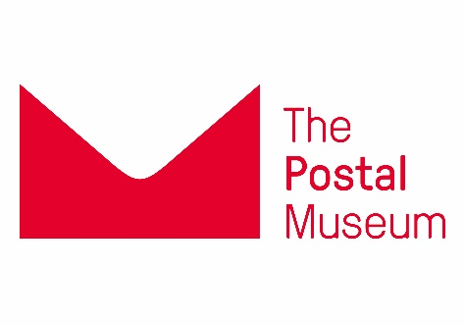

CONFIDENTIAL
APPLICATION FOR EMPLOYMENT

PLEASE COMPLETE IN FULL – Incomplete applications & CVs Will not be accepted
TYPE OR USE BLACK INK TO AID COPYING

Upon completion, please save as a pdf version of this application form to send to hr@postalmuseum.org
Vacancy Post Title:  Designer/Web Editor |  |  | Closing date:  12pm on 11 September 2017
Your Title: | Surname: |  | First Name(s):

PERSONAL DETAILS
Address (For correspondence)  Postcode  How long have you been at this address? | Telephone Number(s):  Mobile:  Home:  E-mail:
National Insurance No: | Do You have a Drivers Licence: Yes/No

PLEASE INDICATE HOW YOU FOUND OUT ABOUT THIS VACANCY

e.g. Online, print or word of mouth – please note the name of the publication or website (if our own website, indicate how you learned of it):

MEMBERSHIP OF PROFESSIONAL BODIES Please list the names of any professional bodies that you are a member of:

INFORMATION IN SUPPORT OF YOUR APPLICATION
Please use this space to provide evidence to show how you meet the role requirements/job criteria. This can include professional activity (paid or voluntary), examples of achievements, evidence of updating knowledge and skills. List any relevant publications and articles. This section MUST be completed in order for us to consider your application. Feel free to attach separate pages or expand the section

INFORMATION IN SUPPORT OF YOUR APPLICATION (cont.)

EMPLOYMENT HISTORY – Including volunteer experience. Please explain any time unaccounted for.
Current /Most recent Employer name & address:
Position held: Full time or Part time:
Start date: Leaving date (If applicable):
Current/last salary: Notice period:
(Indicate Basic salary, Overtime and Bonus Payments Separately)
Reason for leaving this employment:
Please summarise your current duties/responsibilities:

(Please expand/continue on a separate sheet if necessary).
EMPLOYMENT RECORD FOR THE LAST 10 YEARS (Excluding current employment; most recent first. Please fill in any gaps in record. Include relevant unpaid work)
Employer name & address, position held, full or part time |  |  | Dates of employment (from m/yyyy to m/yyyy) | Summary of duties and reason for leaving  (Please expand/continue on a separate sheet if necessary).
 | EDUCATION and TRAINING HISTORY: evidence of qualifications obtained may be required
 | University, College, School name and location | Subjects studied |  | Qualification(s) gained and dates obtained (if currently undertaking any studies, please indicate the date the result is likely to be known)

AVAILABILITY
Interviews are expected to be held: Week commencing 25 September 2017

- All Postal Museum staff will be DBS checked. This is a requirement for employment to be confirmed.
- The Postal Museum complies fully with the DBS Code of Practice and Disclosure.
- All applicants checked are treated in the same manner and in accordance with the DBS’ Code of Practice.
- Criminal record will not necessarily prevent you from obtaining the position within our organisation.

SUPPLEMENTARY INFORMATION

Equality Act 2010
The Postal Museum wishes to ensure that disabled people are not discriminated against either directly or indirectly and if you are selected for interview and consider yourself disabled we may contact you to find out if there are any particular arrangements you may require for the interview or future employment

Do you consider yourself to be disabled? Yes / No (Please circle)
If yes, please specify the nature of the disability:

Are there any adjustments which you consider need to be made for the purpose of:

a) The interview?

b) The job, if offered it?
Please note: If successful you may be asked to complete a more comprehensive and confidential medical form.

THE REHABILITATION OF OFFENDERS ACT 1974
Do you have an unspent criminal record under the Rehabilitation of Offenders Act 1974?
Yes / No (Please circle)
If “Yes”, what was
a) The nature of the offence?

b) The date of the offence?

THE IMMIGRATION AND ASYLUM ACT 1996
Do you require a work permit to be employed in the UK? Yes / No

If Yes, do you currently hold a UK work permit? Yes / No
Please note: all candidates who are invited for interview will be asked for their Right to Work documentation (e.g. passport showing EEA citizenship or entitlement to work in the UK)
DECLARATION
I declare that the information given in this document is correct to the best of my knowledge and belief. I understand that any wilful misstatements render me liable to disqualification or to dismissal, if engaged.
I consent to the information I provide being kept on file and processed for recruitment purposes in accordance with the principles of the Data Protection Act 1998.

Signature. . . . . . . . . . . . . . . . . . . . Date:. . . . . . . . . . . . . . . . . .
(if sent by email we will accept your email account name as a substitute signature; you will be asked to sign a hard copy in the event that you are appointed)

